CCNA2 Chapter 7 Practice Test Questions

Which is a difference between RIP version 1 and RIP version 2?

- The routing metric
- The routing algorithm
- Support for authentication
- Support for hierarchical networks

Which of these is a characteristic of RIP v2 that makes it more suitable for modern networks than RIP v1?

- It is a classless routing protocol.
- It is a classful routing protocol.
- Its metric can accommodate a larger network.
- It has a lower administrative distance.

Why is the use of a multicast address for RIP v2 routing updates an improvement over the use of a broadcast address?

- Routers give priority to multicast addressed packets when they are received whereas broadcast receives low priority.
- It eases the pressure on the limited number of usable IP addresses.
- Hosts that are not running RIP will discard the packets at layer 2 instead of processing them as far as layer 4.
- It enables the routers to learn about all other routers in the system that are running RIP v2.

What information is found in a RIP v2 update but not in a RIP v1 update? (Choose 2)

- Network address
- Subnet mask
- Number of hops
- Next hop address
- Default route

How do RIP v1 and RIP v2 compare in their features to avoid routing loops?

- RIP v1 uses the split horizon rule but RIP v2 does not need to use it.
- RIP v1 takes longer to count to infinity than RIP v2.
- RIP v2 has a higher default value for its holddown counter.
- RIP v2, being classless, is less prone to develop routing loops.
- Both versions use the same methods of avoiding routing loops.

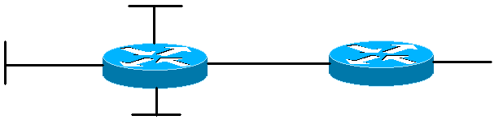
192.168.1.0/27
192.168.1.32/27
192.168.1.64/27
192.168.1.96/27
192.168.1.252/30

Why should RIP v2 be run on this network rather than RIP v1?

- The major network address has been subnetted.
- The subnets are discontiguous.
- VLSM has been used.
- CIDR has been used.

Why should RIP v2 not be run with default settings on a network with discontiguous subnets?

- It summarises to class boundaries so that remote discontiguous networks are not recognised.
- It does not send subnet mask information in its routing updates, so it cannot recognise subnets unless they are directly connected.
- It has a maximum hop count of 15 and this is not enough to reach discontiguous subnets.
- It does not support VLSM or CIDR so that it cannot carry out the summarising needed for discontiguous networks.

172.16.3.0/24
B
A

172.16.2.0/24

172.16.1.0/24

Routers A and B are running RIP v2 with default settings. What networks should A advertise to B?

- 172.16.1.0/24, 172.16.2.0/24 and 172.16.3.0/24
- 172.16.1.0/22
- 172.16.0.0/16
- 172.16.0.0/23 and 172.16.2.0/23

The 192.168.1.0 network has been subnetted using VLSM and all the subnets are contiguous. Router D is the border router leading to another group of networks, and it advertises 192.168.1.0/24 to Router E. All routers in the system are running RIP v2. A packet addressed to 192.168.1.2 arrives at Router E. What will happen?

- Router E will drop the packet because it does not have a route to the required subnet.
- Router E will send the packet on the summary route to Router D and Router D will then forward the packet on to the right subnet.
- Router E will send the packet on its default route to Router D and Router D will then forward the packet on to the right subnet.
- Router E will send the packet to Router D but router D will drop the packet.

Router A has been configured to run RIP with default settings. It’s immediate neighbour, Router B, has been configured to run RIP v2. What is true of the updates?

- The routers are running different versions of RIP and so neither router can read routing updates from the other router.
- Router A will send version 1 updates which can be read by Router B, but Router B will send version 2 updates which cannot be read by Router A.
- Router B will autodetect that Router A is running RIP v1 and will therefore send v1 updates to Router A.
- Router B will send v2 updates to Router A and Router A will read the updates, but ignore information that is specific to v2.

Which are examples of supernetting? (Choose 2)

- 10.10.0.0/12
- 10.10.0.0/16
- 10.10.0.0/21
- 172.19.0.0/12
- 172.19.0.0/16
- 172.19.0.0/21
- 172.19.0.0/24
- 192.168.0.0/21
- 192.168.0.0/24

Which command would propagate a default route across a network where routers are running RIP v2?

- Default-route propagate
- Default-information originate
- Redistribute rip
- Redistribute default-information
A router configuration includes the following:
Router(config)#int fa0/0
Router(config-if)#ip address 172.16.1.0 255.255.255.0
Router(config)#int fa0/1
Router(config-if)#ip address 172.16.2.0 255.255.255.0
Router(config)#int s0/0
Router(config-if)#ip address 172.16.3.0 255.255.255.0
The router is running RIP v1. Would it be sensible to configure serial 0/1 with the IP address 172.16.20.0 255.255.255.252?

- No, because this is not a valid subnet mask for a serial interface.
- No, because this would create an overlap of IP addresses.
- No, because the 172.16.4.0 address should be used next for consistency.
- No, because this would involve VLSM which is not supported by RIP v1.
- Yes, this would be acceptable because it is on a different classful network.

Router A has a summarised route to 172.16.0.0/14. It sends a RIP v2 update including this route to Router B, which is also running RIP v2. What happens?

- Router B installs the summarised route to 172.16.0.0/14 in its routing table (assuming that it has no better route.)
- Router B performs automatic summarisation to the class boundary and installs a route to 172.16.0.0/16.
- Router B performs automatic summarisation to the class boundary and installs routes to 172.16.0.0/16, 172.16.1.0/16, 172.16.2.0/16 and 172.16.3.0/16.
- Router B does not install any route to 172.16.0.0 in its routing table.

Router A has a summarised route to 172.16.0.0/14. It sends a RIP v2 update including this route to Router B, which is running RIP v1. What happens?

- Router B installs the summarised route to 172.16.0.0/14 in its routing table (assuming that it has no better route.)
- Router B performs automatic summarisation to the class boundary and installs a route to 172.16.0.0/16.
- Router B performs automatic summarisation to the class boundary and installs routes to 172.16.0.0/16, 172.16.1.0/16, 172.16.2.0/16 and 172.16.3.0/16.
- Router B does not install any route to 172.16.0.0 in its routing table.

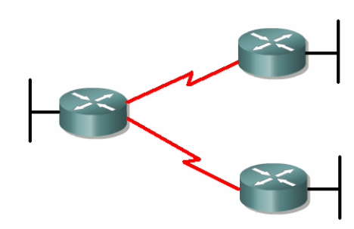

192.168.1.128/27
192.168.1.188/30
192.168.1.0/25

192.168.1.192/27
192.168.1.220/30

Why is there a problem with the addressing scheme above?

- There is an overlap between 192.168.1.220/30 and 192.168.1.192/27
- There is an overlap between 192.168.1.188/30 and 192.168.1.192/27
- There is an overlap between 192.168.1.128/27 and 192.168.1.188/30
- 192.168.1.188 is not a valid network address.
- 192.168.1.220 is not a valid network address.


192.168.7.1
Fa0/0

You want the 192.168.7.0 network to be advertised in routing updates, but you do not want routing updates to be sent out of interface 192.168.7.1. Which commands should you give? (Choose 2)

- Router(config)#router rip
Router(config-router)#network 192.168.7.0
- Router(config)#router rip
Router(config-router)#no network 192.168.7.0
- Router(config)#router rip
Router(config-router)#192.168.7.1 inactive
- Router(config)#int fa0/0
Router(config-router)#shutdown
- Router(config)#router rip
Router(config-router)#passive-interface 192.168.7.1

